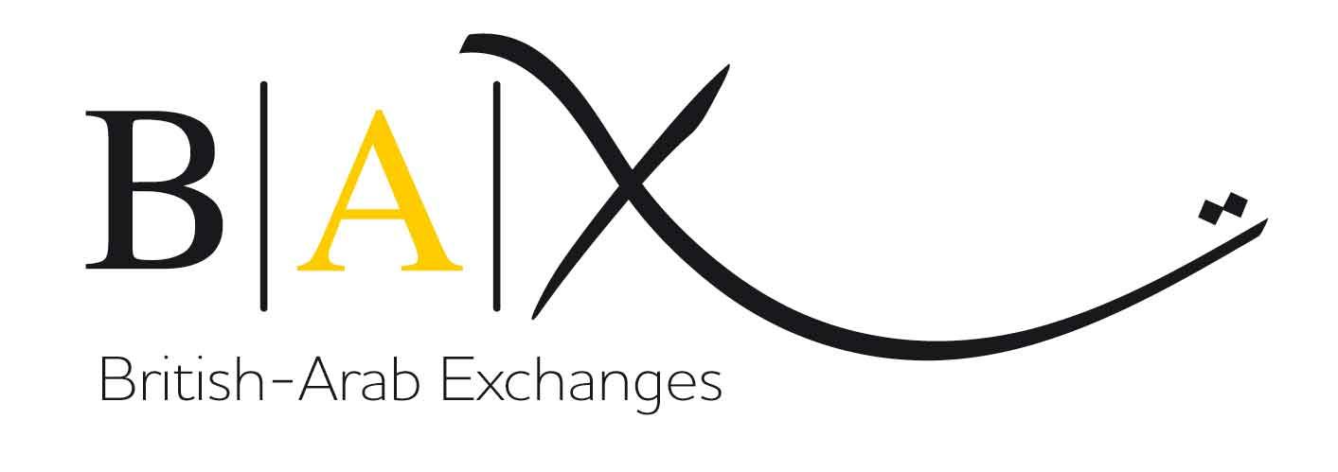

GIFT AID DECLARATION

If you are a UK taxpayer you can increase the value of your gift to us - at no extra cost to yourself!

Details of Donor: Title……. Forename(s)…………………………………….

Surname…………………………………..………………………………………

Address……………….………………………………………………………..……………………………..

…………………………………………….………………..………………………………………………….

Post Code ……………………..…

I want the Charity to treat as Gift Aid all qualifying gifts of money made:

- the enclosed donation of £ ………………..

- all donations I make from the date of this declaration until I notify you otherwise
delete as appropriate

Signature…………………………........................ Date…………………………

Notes:

- You can cancel this declaration at any time by notifying British-Arab Exchanges.

- You must pay an amount of income tax, or capital gains tax, equal to the amount of the tax we reclaim on your donations.

Please return your completed form to:

British-Arab Exchanges, 12a Norham Road, Oxford OX2 6SF (NOT to your bank)

Thank you for your support.

